Issue: MIA Stock Items not coming up in Seradex Search
Duration: Appears to be an issue for some time. Last positive time this was working was fall 2022
What changed: From our Estimator team: I would say Fall it was working cause we noticed the category was incorrect. We then fixed everything regarding the category to include the CAT-MIA, but I since then added more part numbers down in MIA and need this search to find out information and noticed that nothing was popping up on my list. I have even looked at OH part numbers to make sure they were set up correctly with MIA and everything matched.

The category was set as CST-MIA and it needed to be CAT-MIA. There was only a couple that were marked as that but we fixed that.


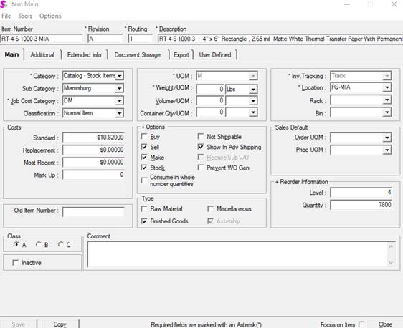

Historical:

From: lauren.koenig@repacorp.com <lauren.koenig@repacorp.com>
Sent: Friday, October 7, 2022 16:27
To: Dan DeCerbo <dan.decerbo@repacorp.com>
Cc: Rochelle Heinl <rochelle.heinl@repacorp.com>; Anna Cross <anna.cross@repacorp.com>; Jessica Parks <jessica.parks@repacorp.com>
Subject: RE: MIA Seradex Search

Well….. I got to looking into the RT-4-6-1000-3-MIA and I was working with Jessica and we got the category switched in the item master to catalog and fixed the current workorder. It is still not pulling up under my list. I created a “Test” Sales order S221007080 and it is now pulling as CAT-MIA. All the other Sales orders that are open are pulling from CST-MIA.

Sales Order Search

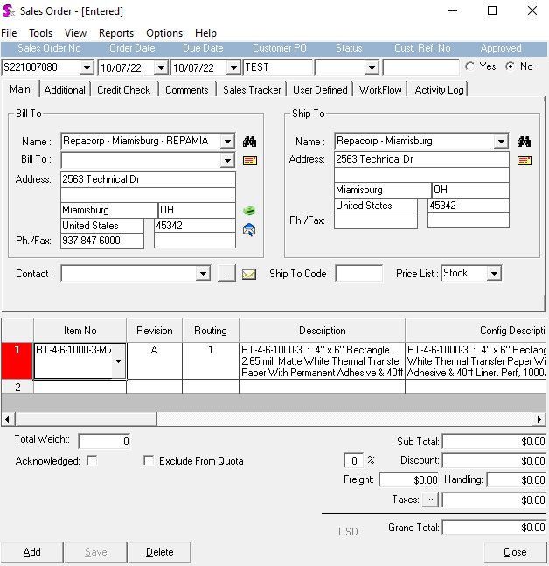
Repacorp Stock Backorder

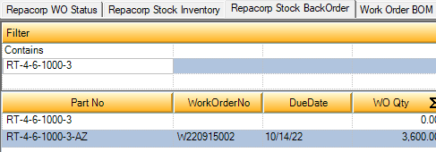

Repacorp Stock Inventory Build

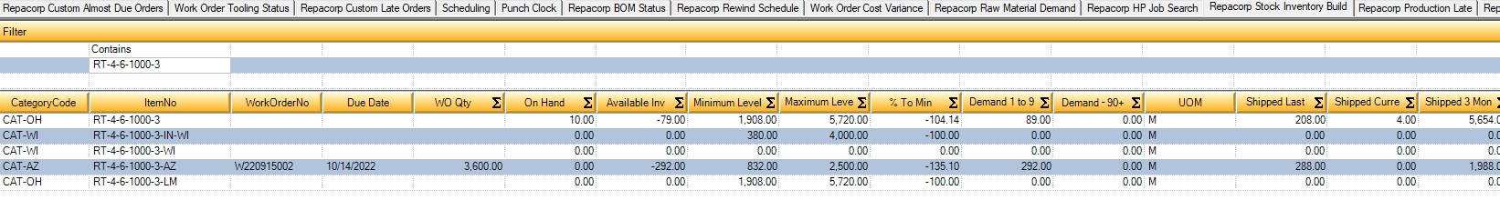

Lauren Koenig

Purchasing Assistant



lauren.koenig@repacorp.com | (937) 667-8496 x 1255

www.repacorp.com

Attention: Due to the impact of COVID-19, our industry is experiencing longer lead times. Please plan well ahead during the pandemic and place your orders accordingly.

From: lauren.koenig@repacorp.com <lauren.koenig@repacorp.com>
Sent: Friday, October 7, 2022 10:30 AM
To: 'Dan DeCerbo' <dan.decerbo@repacorp.com>
Cc: 'Rochelle Heinl' <rochelle.heinl@repacorp.com>; 'Anna Cross' <anna.cross@repacorp.com>
Subject: RE: MIA Seradex Search

Well, that would make sense then! I will look into this today.

Thank you for looking into this.

Thank you,

Lauren Koenig

Purchasing Assistant



lauren.koenig@repacorp.com | (937) 667-8496 x 1255

www.repacorp.com

Attention: Due to the impact of COVID-19, our industry is experiencing longer lead times. Please plan well ahead during the pandemic and place your orders accordingly.

From: Dan DeCerbo <dan.decerbo@repacorp.com>
Sent: Friday, October 7, 2022 9:13 AM
To: lauren koenig <lauren.koenig@repacorp.com>
Cc: Rochelle Heinl <rochelle.heinl@repacorp.com>; Anna Cross <anna.cross@repacorp.com>
Subject: RE: MIA Seradex Search

Lauren,

I had a chance to review this issue. The search is set up to pull all categories for stock items, regardless of location. I did notice that all the other items in the searches you provided have a category code beginning with “CAT”; however, the ones you state are missing from the searches shown in the SO search have a category code of “CST”. I believe this is why they are not shown in the stock searches? Is there a way to change this and try it?

Thanks,

Dan DeCerbo Jr.
Director of IT



dan.decerbo@repacorp.com | www.repacorp.com

(937) 667-8496 x 511 | direct: (937) 877-2391

From: lauren.koenig@repacorp.com <lauren.koenig@repacorp.com>
Sent: Wednesday, October 5, 2022 09:47
To: Dan DeCerbo <dan.decerbo@repacorp.com>
Cc: Rochelle Heinl <rochelle.heinl@repacorp.com>
Subject: MIA Seradex Search

Hey Dan, Here is what I was talking about with the MIA stock items.

Example…RT-4-6-1000-3-MIA….(W220829004)

This is from the Repacorp Backorder List

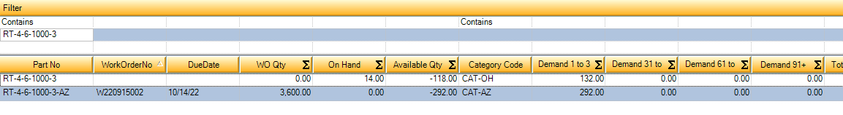
Repacorp Stock Inventory Build

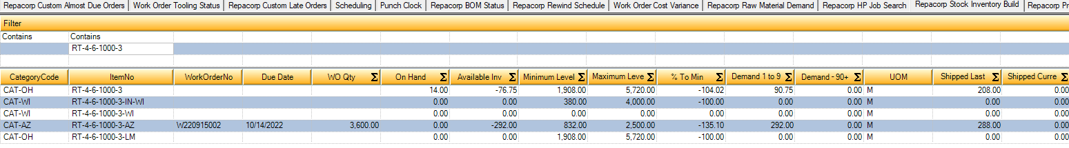

We currently have all these sales orders in and we have no inventory so it should be triggering a backorder.

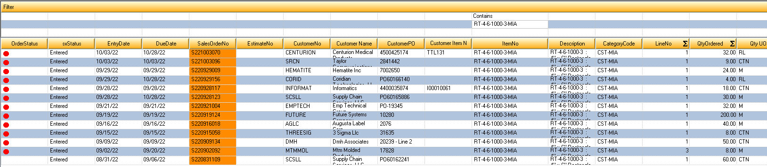

Thank you,

Lauren Koenig

Purchasing Assistant



lauren.koenig@repacorp.com | (937) 667-8496 x 1255

www.repacorp.com

Attention: Due to the impact of COVID-19, our industry is experiencing longer lead times. Please plan well ahead during the pandemic and place your orders accordingly.

